Lanarkshire U13/17 Junior Open - 2026

Sir Craig Reedie Badminton Centre

28th & 1st March 2026

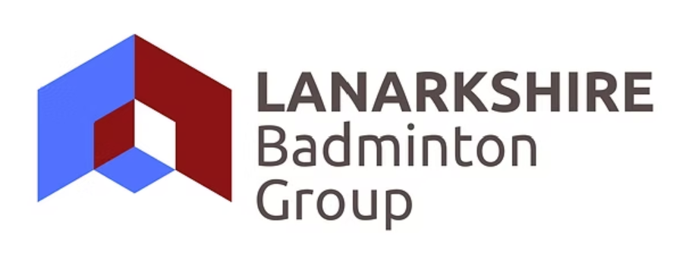

Lanarkshire Badminton Group

- The Tournament will be conducted under the rules of BADMINTONscotland, including the prohibition of doping for which tests may be carried out. Please note that every player must be a current individual member of Badminton Scotland to gain entry to the event.
- Players eligible to play U13 events must be born in 2014 or later, players eligible for the U17 events must be born in 2010 or later.
- Players can only play one level or mixed doubles event. U13 players can ‘play up’ to the U17 events but U17 players cannot ‘play down’.
- All matches will be the best of three games of 21 points, with normal setting as required.
- PLAYERS ABSENT WHEN CALLED UPON TO PLAY WILL BE SCRATCHED –
players should inform the tournament organiser if, for any reason, they are unable to play - An unannounced withdrawal will be reported to BADMINTON SCOTLAND and a warning letter may be sent.
- A separate entry must be made by each player.
- No player shall be accepted for a doubles event unless entries have been received from both players.
- LBG reserves the right to refuse any entry without giving their reasons.
- LATE ENTRIES and ENTRIES SENT WITHOUT THE APPROPRIATE ENTRY
FEES will NOT be accepted. ON-LINE ENTRY IS AVAILABLE FOR THIS TOURNAMENT via TOURNAMENT SOFTWARE. Use the following url: https://badmintonscotland.tournamentsoftware.com/tournament/B94F7D2D-A973-4FCB-B1DE-4B48C0D07168. No entry will be accepted from any player who has taken part in any unauthorised tournament, league, or match.
- Please note that each player will have at least two matches per event – we will play a consolation for each event where required.
- Paper entries must be sent by Monday 16th February 2026 to:
Frank Turnbull, 5 Glengowan, Millheugh Brae, Larkhall, Lanarkshire, ML9 1AS, accompanied by the appropriate Entry Fees.
Other contact details are - Mob: 07717 827074 Email: fturnbull16@gmail.com
- Online entries via Tournament Software will close at midnight on Monday 16th February 2026
- All players from both age groups must check in at 08.45am and hold themselves ready to play for 9.15am on Saturday 28th February and Sunday 21st March.
- Current BADMINTON SCOTLAND clothing regulations apply.
- Both age groups Boys and Girls singles will start at 9.15am on Saturday 28th February, all Boys and Girls Doubles will start on Saturday 28th February in the afternoon – check Tournament Software for approximate start times. Both age group’s Mixed Doubles will start at 9.15am on Sunday 1st March. We will play all singles semi-finals at 12 noon on Sunday 1st March. We may play some of the doubles semi-finals at 12.00 Sunday if we have a sufficiently high entry. Finals for both age groups will start Sunday 1st March afternoon at 1.30pm. Play should be completed before 5pm.
- A break not exceeding 2 minutes will be allowed between the 1st and 2nd games and 2nd and 3rd games for all matches. Coaching breaks will follow the Badminton Scotland Guidelines.
- By entering this competition your entry details will be automatically held for at least 3 years. If you want your personnel details to be removed from LBG’s database, please tick the box on the entry form.
- Neither the Lanarkshire Badminton Group or Badminton Scotland will be responsible or liable for any injury or damage to property. Players should make their own insurance arrangements to cover injury and damages that may incur.
20 Sir Craig Reedie Badminton Centre address: 40 Bogmoor Place, Glasgow, G51 4TQ, telephone: 0141 4451218
THE RESULTS FROM THIS TOURNAMENT WILL BE INCLUDED IN THE SCOTTISH RANKING LIST – THIS IS A BS GOLD TOURNAMENT.

Lanarkshire U13/U17 Junior Open ENTRY FORM 2026

ON-LINE ENTRY IS AVAILABLE FOR THIS TOURNAMENT
Under 13 Events

EVENT NAME ENTRY FEE £
BOYS SINGLES  Sat am |  | £20.00
GIRLS SINGLES Sat am |  | £20.00
MENS DOUBLES  Sat pm |  | £20.00
PARTNER
LADIES DOUBLES  Sat pm |  | £20.00
PARTNER
MIXED DOUBLES SUN am |  | £20.00
PARTNER
TOTAL DUES (Including SBU levy): £35 if playing 2 events, £48 if playing all 3 events

Semi - Finals Boys & Girls Singles SUNDAY Noon Finals SUNDAY 1.30pm

Under 17 Events

EVENT NAME ENTRY FEE £
BOYS SINGLES  Sat am |  | £20.00
GIRLS SINGLES Sat am |  | £20.00
MENS DOUBLES  Sat pm |  | £20.00
PARTNER
LADIES DOUBLES  Sat pm |  | £20.00
PARTNER
MIXED DOUBLES SUN am |  | £20.00
PARTNER
TOTAL DUES (Including SBU levy): £35 if playing 2 events, £48 if playing all 3 events

Semi - Finals Boys & Girls Singles SUNDAY Noon Finals SUNDAY 1.30pm

Cheques should be made payable to LANARKSHIRE BADMINTON GROUP. Please accept the entries for the events against which I have placed my name.
I enclose £ …………… being the amount of my Entrance Fee including levy to BADMINTONscotland

NAME & ADDRESS ……………………………………………. ID NUMBER SC ………………..
DoB ………………………..
(BLOCK CAPITALS PLEASE) …………………………………………………
Post Code ………………………….
Telephone ………………………….
E-mail address ………………………………………...……………………..
(please print)

I declare that I am a member of …………………………………… Badminton Club affiliated to
BADMINTON…………………………. OR I confirm that I have an individual affiliation (delete as appropriate) I also confirm that I have not taken part in any unauthorised Tournament, League or Match
I would like my personal details to be removed from the LBG database after the competition - yes/no

Please remove my personal details from the LBG database ………….

SIGNED………………………………………………

CLOSING DATE FOR ENTRIES: Monday 16th February, 2026

